PPL LISP ASSIGNMENT9

NAME: SANSKAR SANJAY DUDHE, DIV:2, SYComp

LISP Program to write function to find nth element from list L:

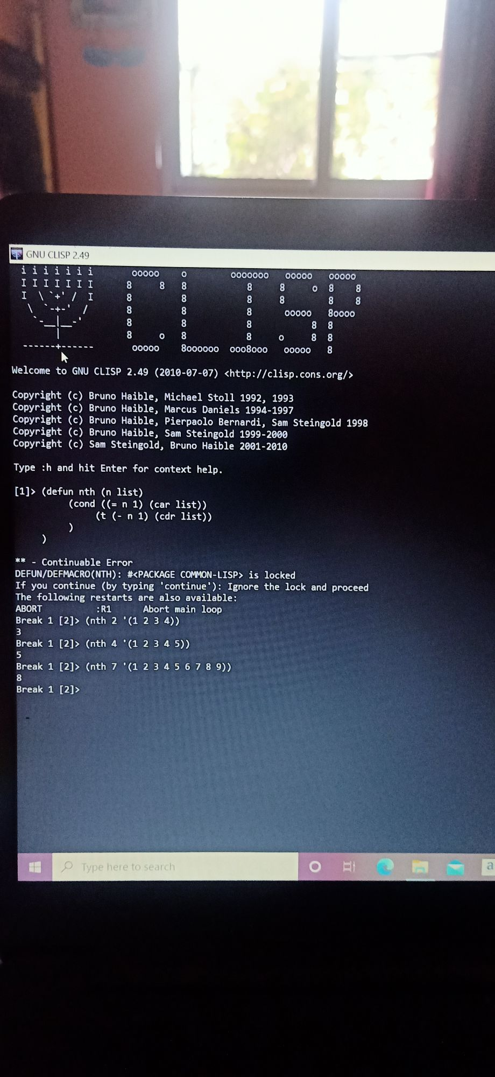

LISP Program to compute factorial of number using recursion:

